## ****Steps To Register For Azure FREE Trial Account****

1. Go to the https://azure.microsoft.com/en-us/

2. Click on ****Free Azure Account**** on the top right corner.

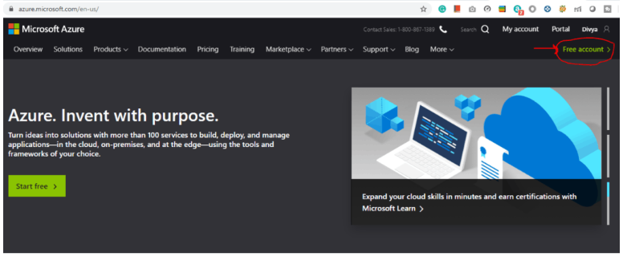

1. Click on ****Start Free.****

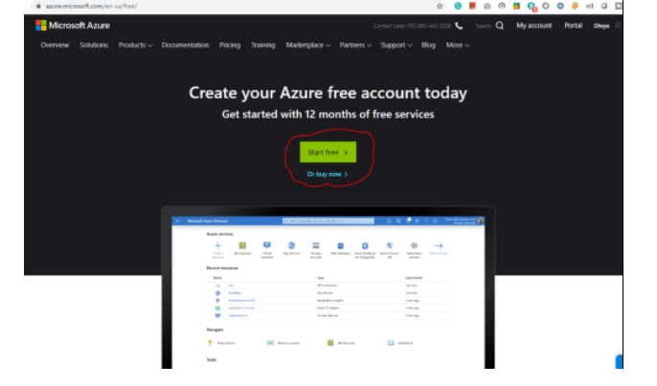

1. Sign-in/Sign-up for a Microsoft account using an email address and password.

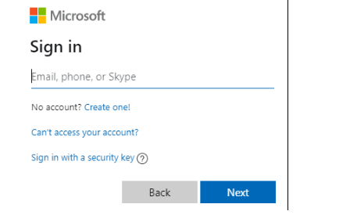

5. Enter your Country/Region and Date of Birth and click next.

6. Enter the ****verification code**** received on the email address and click next.

7. Type the captcha you see on your screen and click on next.

8. You’ll be redirected to the Azure Sign-up page. Enter your Region, Name, Phone number, Email address. ****Note****: You should use the same email address for Azure sign-up and for the Microsoft account.

9. Verify your phone number by clicking Text Me or Call Me and enter the verification code received.

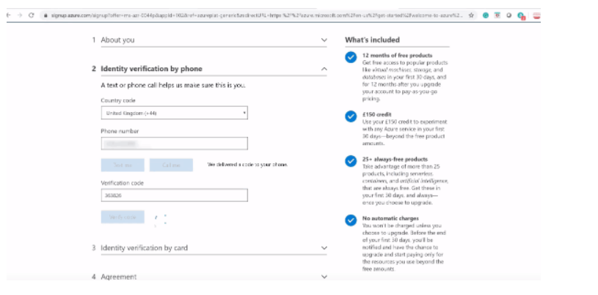

1. Enter the payment details. Make sure you have a ****Master Card/American Express/ Visa Credit card**** and international payments should be enabled.

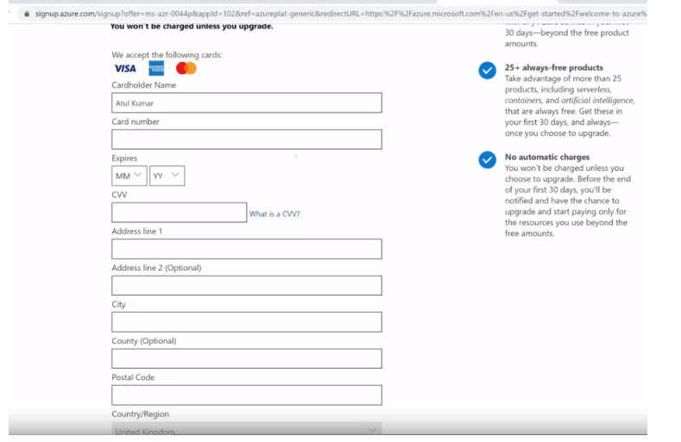

1. Check the Terms and Conditions and click Sign-up.

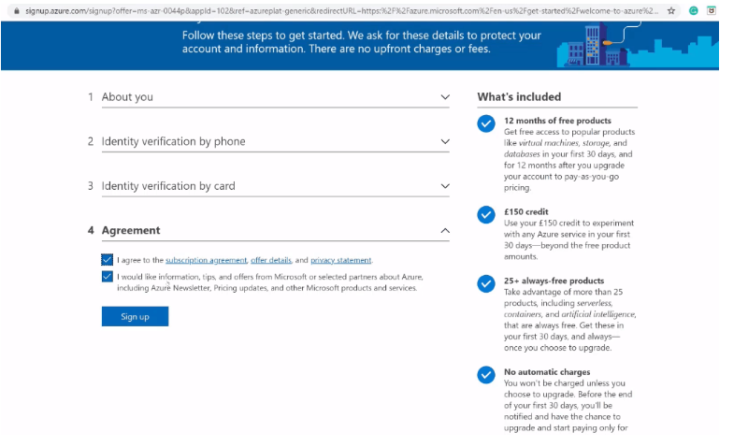

12. You have successfully created a Microsoft Azure free account and now have a lumpsum balance of ****$200****.

13. Click on ****Portal**** on the top right corner of the screen. You’ll be redirected to the Azure portal.

14. If you have exhausted your free credit then you have to move to the Pay as you go subscription policy.

if you have crossed the limit or time limit then you will get “your subscription is disabled and cannot perform operations  until its re-enabled”

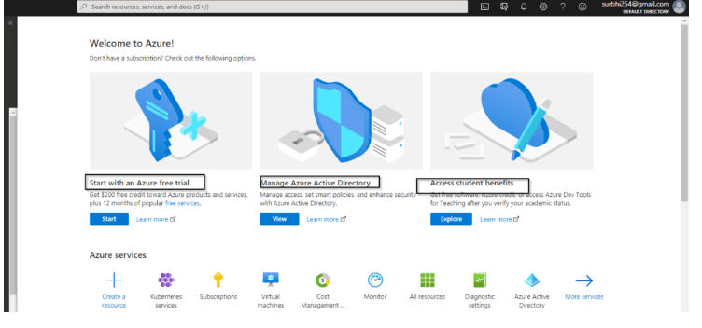

**You can not create multiple Microsoft azure free accounts or after one account expires to another account for free credit of 200$ using a single Credit card.**